Time Series Forecasting of Freight Transport through Cochin Port
Rameesha T V¹, Goutham Sarang², Alosh Denny³, Augustine Anish⁴, Tanu Shree⁵ and Jayalakshmi PE⁶
¹ ^{,2} Scientist B, KSCSTE- National Transportation Planning and Research Centre
^{3,4,5,6} B Tech Student, Cochin University of Science and Technology
Abstract. The abstract should summarize the contents of the paper in short terms, i.e. 150-250 words.
Keywords: First Keyword, Second Keyword, Third Keyword.
- Introduction (to be edited by Dr. Rameesha and Dr. Goutham)
Ports are important hubs for trade, especially when it comes to exchanging goods between the sea and the land, which plays a very important role in the economies of developing nations as ports draw both industry and population concentration. The area served by the port is known as its hinterland, it tis the region that a port uses to distribute and draw traffic, as well as to market its services and engage with people.
- Study Area (to be edited by Dr. Rameesha and Dr. Goutham)

- Methodology

3.1 Data Collection and Exploration (to be edited by Dr. Rameesha and Dr. Goutham)

- 3.2 Time Series Decomposition and Stationarity Check (to be edited by Dr. Rameesha and Dr. Goutham)

3.3 Time series models (to be edited by CUSAT students)
Please give a description of each method

Linear Regression. Linear Regression is a fundamental statistical model used in predictive analytics and time series forecasting. Its core strength lies in establishing a linear association between a dependent variable and one or more independent variables. Linear regression offers a straightforward and interpretable approach to initiate your time series forecasting of freight transport. It provides a baseline model and helps understand the basic linear relationships present in the data.

Random Forest. Random Forest is an ensemble learning algorithm that constructs multiple decision trees during the training phase and combines their predictions to improve overall accuracy and robustness. It operates by introducing randomness in the tree construction process, ensuring that each tree is trained on a different subset of the data and features. This approach helps mitigate overfitting and enhances the model's ability to handle complex relationships and non-linear patterns within the data.

CatBoost (Categorical Boosting). CatBoost is a powerful open-source gradient boosting framework developed by Yandex. It is designed to handle categorical features efficiently, making it particularly useful for datasets with high cardinality categorical variables. CatBoost employs ordered target encoding and other advanced techniques to improve the handling of categorical data. Additionally, it implements various optimizations and regularization methods to prevent overfitting and enhance overall model performance.

LightGBM (Light Gradient Boosting Machine). LightGBM is a highly efficient and scalable implementation of the gradient boosting decision tree algorithm. It is particularly well-suited for handling large-scale data and high-dimensional features. LightGBM employs a novel technique called Gradient-based One-Side Sampling (GOSS) to filter out less informative data instances during training, resulting in faster convergence and improved efficiency.

Hidden Markov Model (HMM). Hidden Markov Model is a statistical model that describes a Markov process with unobserved (hidden) states. It is widely used in various domains, including speech recognition, natural language processing, and bioinformatics. HMMs assume that the observed data is generated by an underlying, unobservable Markov chain, where the current state depends solely on the previous state. The model's strength lies in its ability to capture temporal dependencies and model sequential data effectively.

- Results and Discussion
  - Model Evaluation and Forecasting (to be edited by CUSAT students)
The dataset used for training the models included the freight transport volume through Cochin Port from the years 2018-2022. Selecting appropriate metrics to evaluate the performance of each model employed for time series forecasting of freight transport through Cochin port is critical. Here’s a breakdown for potential metrics and consideration tailored to each model:

Mean Square Error (MSE)*. measures the average squared distance between the actual and the predicted value, giving more weight to larger errors.

Root Mean Square Error (RMSE)*. measures the error in the same units as the dependent variable (freight transport volume) and is often easier to interpret in a practical context.

Mean Absolute Error (MAE)*. captures the average absolute difference between predicted and actual values. Unlike MSE, it doesn't penalize large errors as heavily, making it less sensitive to outliers in the data.

R² (Coefficient of Determination)^. is a statistical measure that represents the proportion of the variance in the dependent variable (freight transport volume) that can be explained by the independent variables (per-year traffic volume). In our context, R² indicates how well the model fits the historical data and explains the variations in freight transport volume over time.

Mean Directional Accuracy (mDA)^. is a metric specifically designed for evaluating the directional accuracy of time series forecasting models. It measures the proportion of times the model correctly predicts the direction of change (increase or decrease) in the freight transport volume compared to the previous time period.

* lower value is desired; ^ higher value is desired

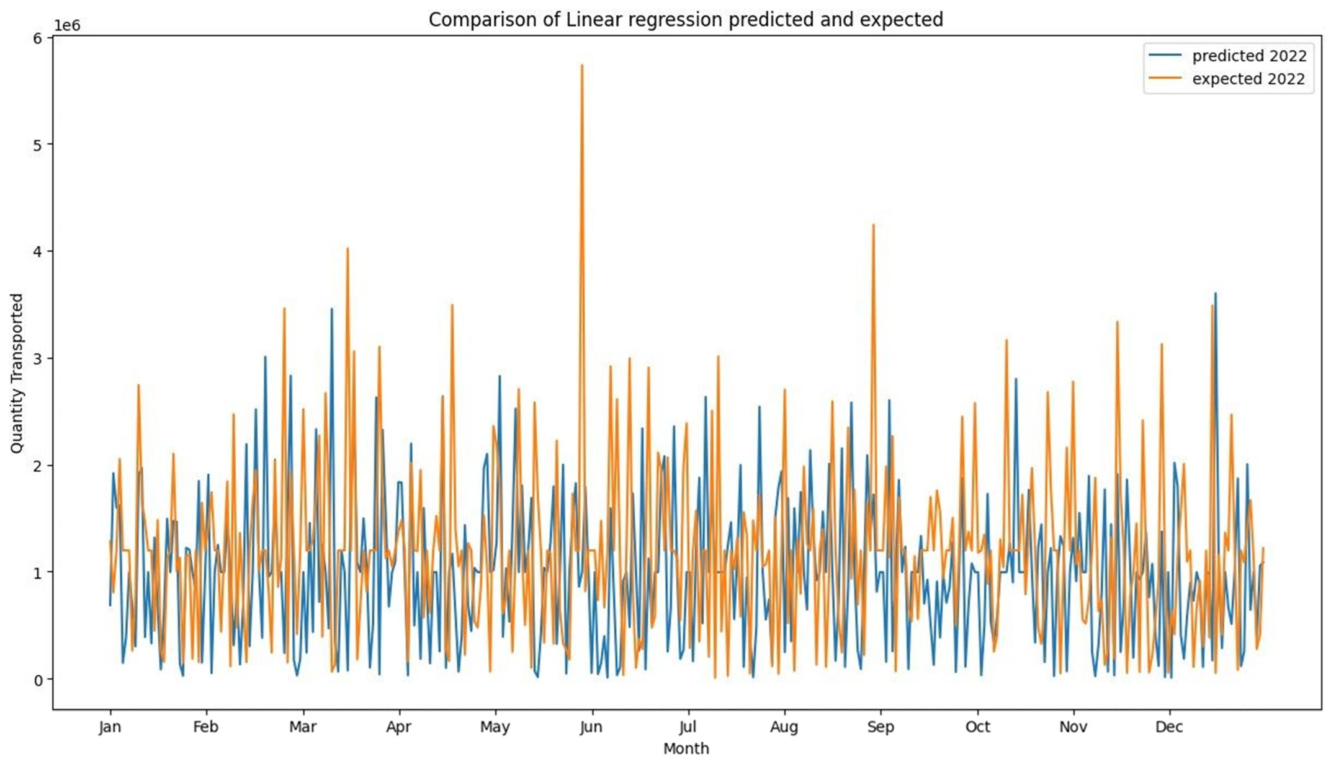Fig 5.1.1: Model evaluation on 2022 export freight data using Linear Regression

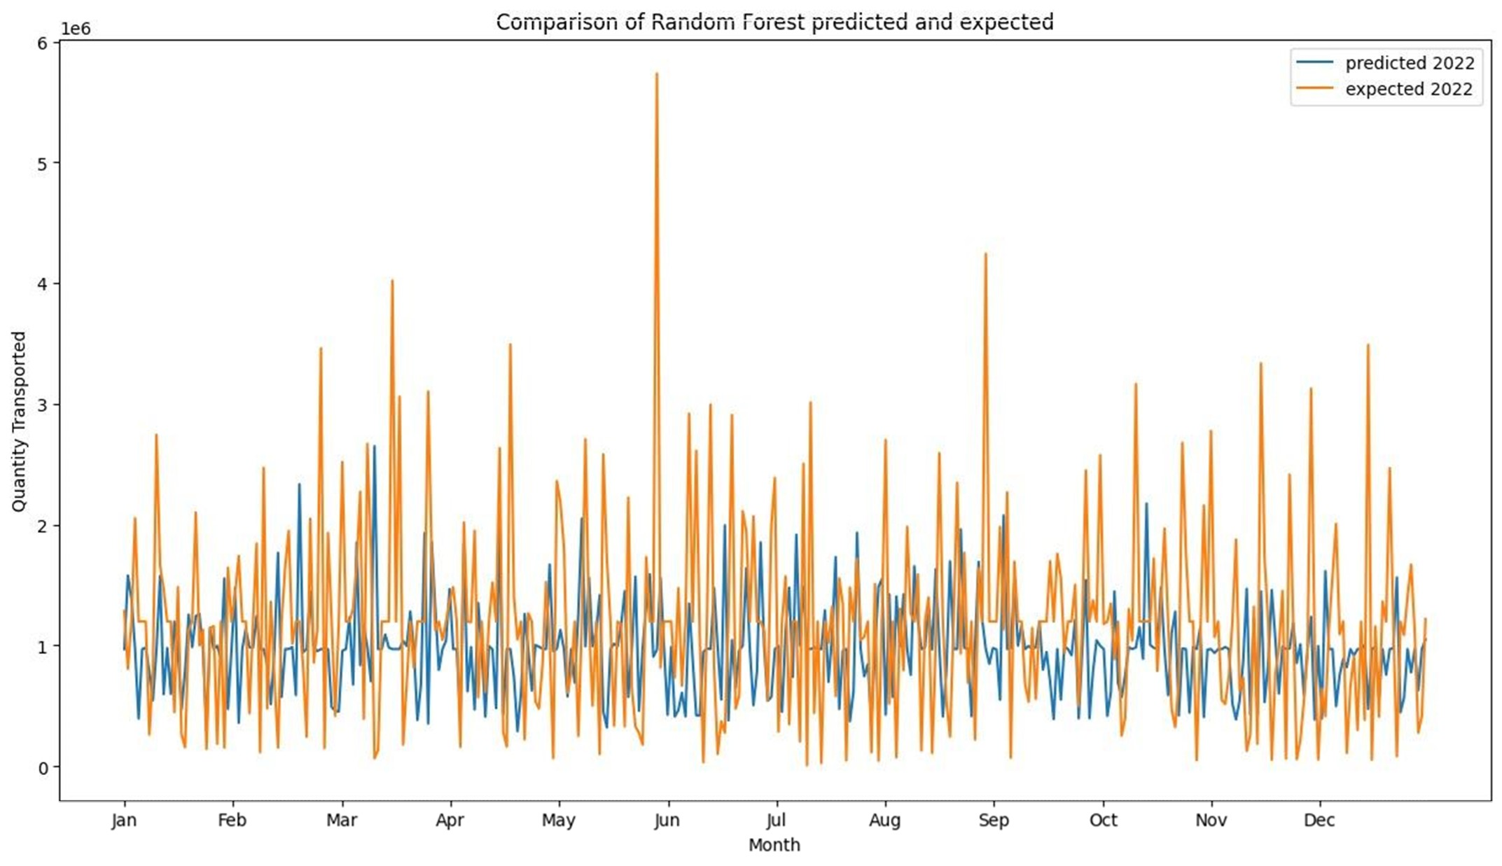
Fig 5.1.2: Model evaluation on 2022 export freight data using Random Forest

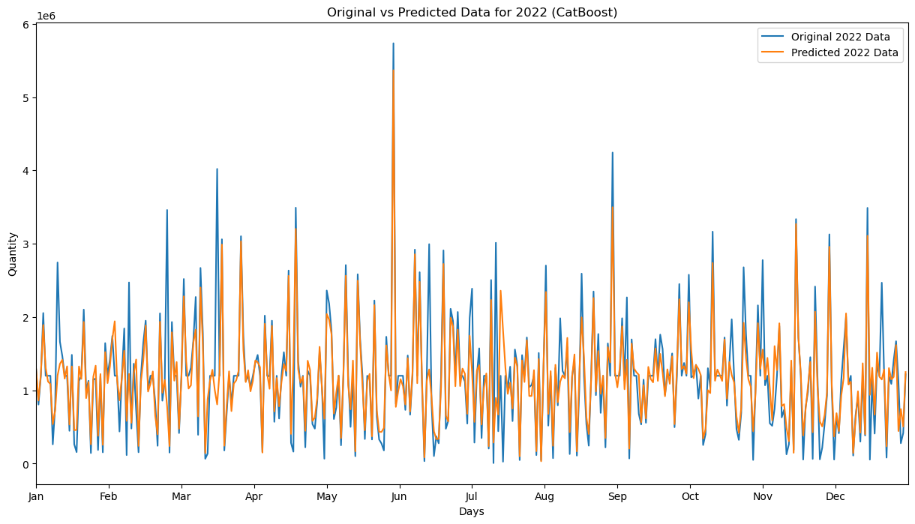
Fig 5.1.3: Model evaluation on 2022 export freight data using CatBoost

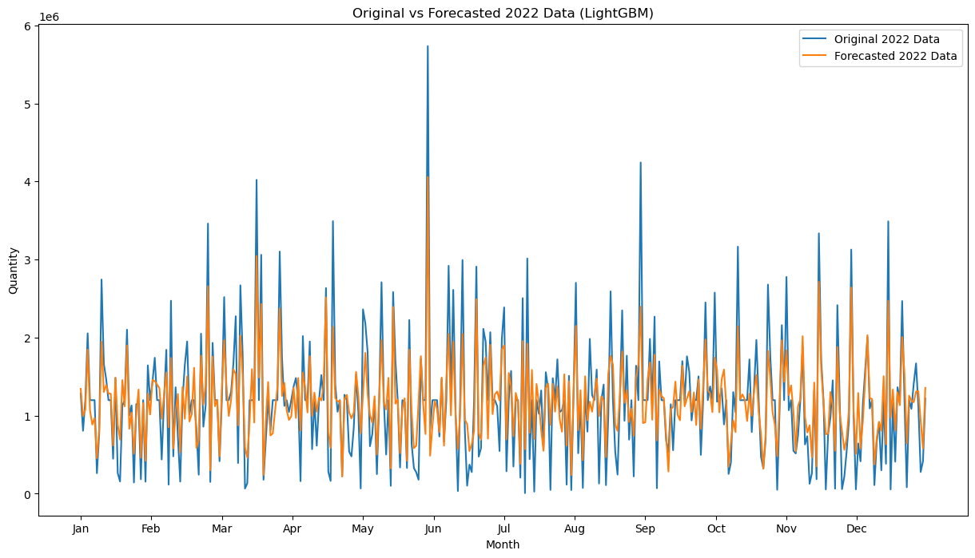
Fig 5.1.4: Model evaluation on 2022 export freight data using LightGBM

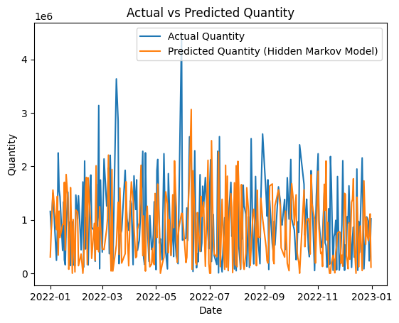
Fig 5.1.5: Model evaluation on 2022 export freight data using Hidden Markov Model
Table 1. Summary of metrics for the potential best performing time series models.
Model | MSE | RMSE | MAE | R² | mDa
Linear Regression | 0.871 | 0.93 | 0.991 | 0.852 | 0.899
Random Forest | 1.124 | 1.06 | 1.244 | 0.798 | 0.849
CatBoost | 1.223 | 1.105 | 1.343 | 0.752 | 0.801
LightGBM | 2.247 | 1.498 | 2.367 | 0.602 | 0.702
Hidden Markov Model | 3.111 | 1.763 | 3.231 | 0.499 | 0.648
  - Model Validation (to be edited by CUSAT students)
Validating the selected models is crucial to ensure their reliability and effectiveness in forecasting freight transport through Cochin Port. The models undergo validation using the dataset covering the freight transport through the years 2023-2028 and their forecasting capabilities are assessed for the same timeframe.

Linear Regression

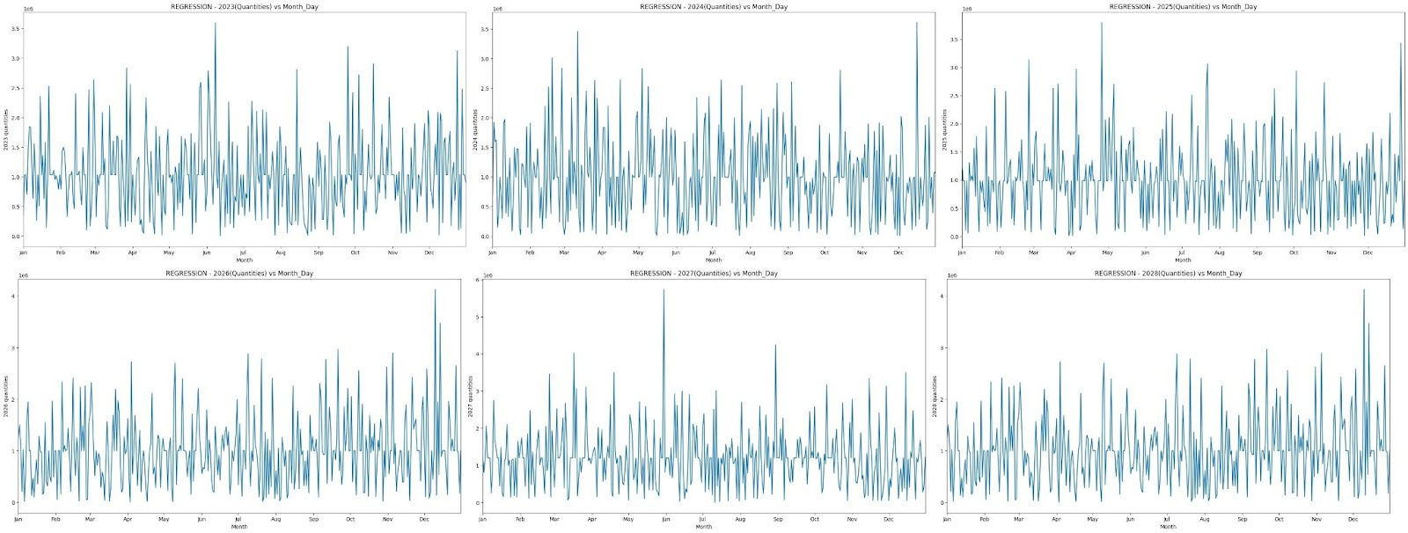
Fig 5.2.1: In clockwise configuration, the forecasted export freight data from 2023-2028 using Linear Regression.

Random Forest

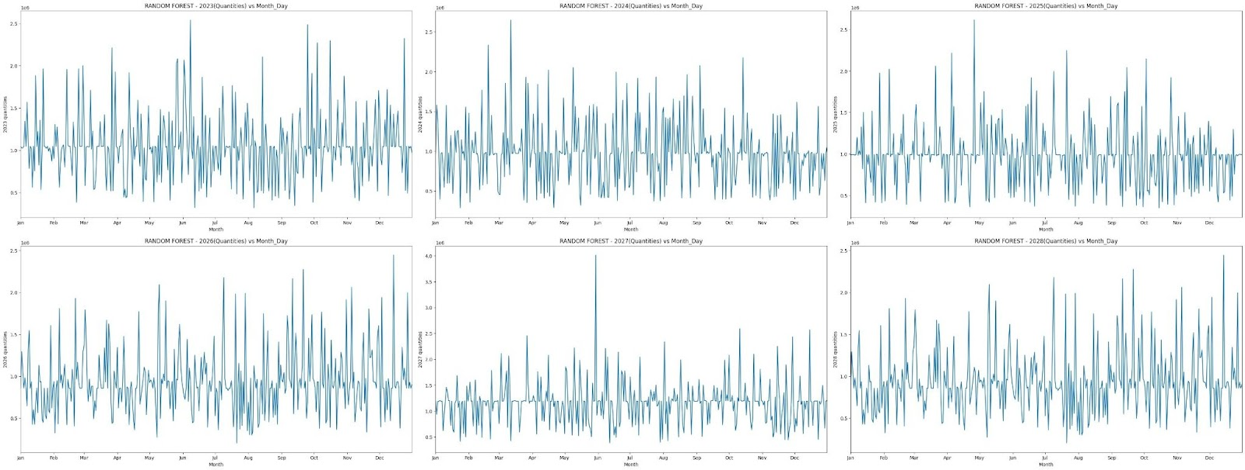
Fig 5.2.2: In clockwise configuration, the forecasted export freight data from 2023-2028 using Random Forest.

CatBoost

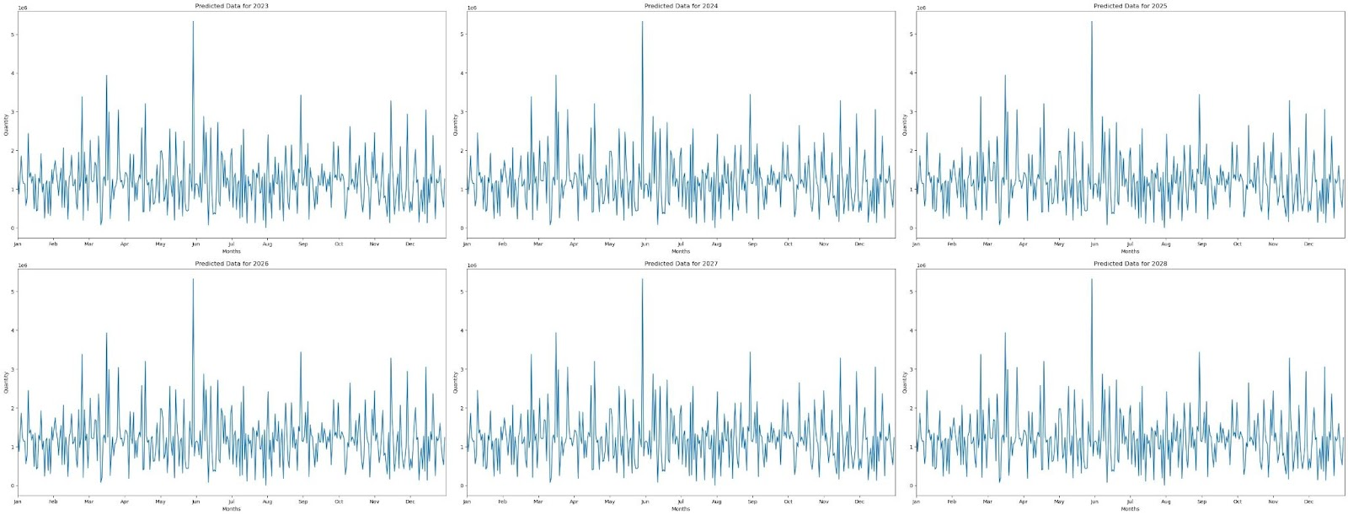
Fig 5.2.3: In clockwise configuration, the forecasted export freight data from 2023-2028 using CatBoost.

LightGBM

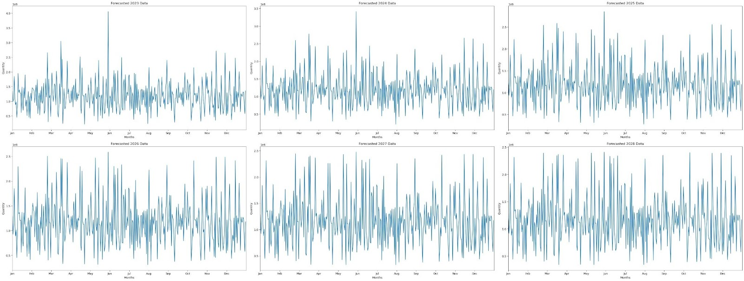
Fig 5.2.4: In clockwise configuration, the forecasted export freight data from 2023-2028 using LightGBM.

Hidden Markov Model

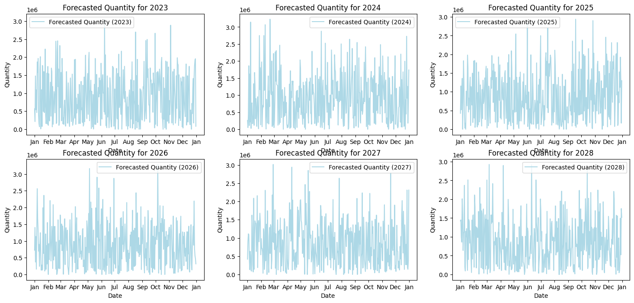
Fig 5.2.5: In clockwise configuration, the forecasted export freight data from 2023-2028 using HMM.
- Conclusion (to be edited by CUSAT students and Dr. Rameesha)
From the five aforementioned candidates chosen for time series forecasting, we draw the inference that Linear Regression, Random Forest and CatBoot displays the least errors and highest accuracies. From these three candidates, we thus conclude that Linear Regression is the most suitable candidate for time series forecasting of export freight data through Cochin Port for the years 2023-2028.
- Reference (to be edited by Dr. Rameesha)
  - A Subsection Sample
Please note that the first paragraph of a section or subsection is not indented. The first paragraphs that follows a table, figure, equation etc. does not have an indent, either.
Subsequent paragraphs, however, are indented.

Sample Heading (Third Level). Only two levels of headings should be numbered. Lower level headings remain unnumbered; they are formatted as run-in headings.

Sample Heading (Forth Level). The contribution should contain no more than four levels of headings. The following Table 1 gives a summary of all heading levels.
Table 1. Table captions should be placed above the tables.
Heading level | Example | Font size and style
Title (centered) | Lecture Notes | 14 point, bold
1st-level heading | 1 Introduction | 12 point, bold
2nd-level heading | 2.1 Printing Area | 10 point, bold
3rd-level heading | Run-in Heading in Bold. Text follows | 10 point, bold
4th-level heading | Lowest Level Heading. Text follows | 10 point, italic
Displayed equations are centered and set on a separate line.
x + y = z (1)
Please try to avoid rasterized images for line-art diagrams and schemas. Whenever possible, use vector graphics instead (see Fig. 1).

Fig. 1. A figure caption is always placed below the illustration. Short captions are centered, while long ones are justified. The macro button chooses the correct format automatically.
For citations of references, we prefer the use of square brackets and consecutive numbers. Citations using labels or the author/year convention are also acceptable. The following bibliography provides a sample reference list with entries for journal articles [1], an LNCS chapter [2], a book [3], proceedings without editors [4], as well as a URL [5].

References
- Author, F.: Article title. Journal 2(5), 99–110 (2016).
- Author, F., Author, S.: Title of a proceedings paper. In: Editor, F., Editor, S. (eds.) CONFERENCE 2016, LNCS, vol. 9999, pp. 1–13. Springer, Heidelberg (2016).
- Author, F., Author, S., Author, T.: Book title. 2nd edn. Publisher, Location (1999).
- Author, F.: Contribution title. In: 9th International Proceedings on Proceedings, pp. 1–2. Publisher, Location (2010).
- LNCS Homepage, http://www.springer.com/lncs, last accessed 2016/11/21.

